ML code for finding the stages of antenna

import numpy as np # linear algebra

import pandas as pd # data processing, CSV file I/O (e.g. pd.read_csv)

import os

for dirname, _, filenames in os.walk('/kaggle/input'):

    for filename in filenames:

        print(os.path.join(dirname, filename))

%matplotlib inline

import matplotlib.pyplot as plt

import seaborn as sns

import warnings

warnings.filterwarnings('ignore')

df = pd.read_csv("lung_data.csv")

df.info()

df.head()

| **e_field** | **h_field** | **stage_of_cancer** |
| --- | --- | --- |
| 0 | -0.875761 | -0.793068 | Benign |
| 1 | 2.894581 | 0.201416 | Benign |
| 2 | -0.745797 | -0.566857 | Benign |
| 3 | 1.094870 | -0.039563 | Malignant (Early) |
| 4 | 0.587965 | 0.221265 | Malignant (Mid) |
|  |  |  |  |

df['stage_of_cancer'].unique()

array(['Benign', 'Malignant (Early)', 'Malignant (Mid)',

'Malignant (Late)'], dtype=object)

df['stage_of_cancer'] = df['stage_of_cancer'].replace({'IA': 1, 'IB' : 1,'IIA':1,

                                                       'IIB':1,'IIIA':2,'IIIB':2,'IV':2})

df=df.fillna({'stage_of_cancer': 0, 'days_to_cancer': 0, 'race': 'Others'})

try:

       df['stage_of_cancer'] = df['stage_of_cancer'].astype('category')

except:

       pass  # Handle potential errors if conversion fails

sns.pairplot(df.drop(columns=['stage_of_cancer']));

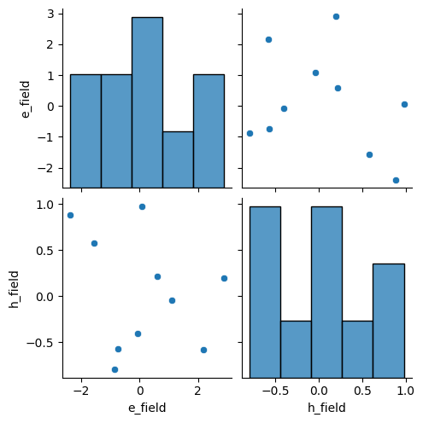

numeric_columns = df.select_dtypes(include=[np.number]).columns

heatmap_data = df[numeric_columns].corr()

sns.heatmap(heatmap_data, annot=True, cbar=False, cmap='Blues', fmt='.1f')

col=[ 'e_field','h_field','stage_of_cancer']

fig = plt.figure(figsize=(15,15))

for i in range(len(col)):

    plt.subplot(3,2,i+1)

    plt.title(col[i])

    sns.histplot(data=df,y=df[col[i]],hue='stage_of_cancer')

plt.tight_layout()

plt.show()

# Assuming valid categories are 'Early Stage', 'Malignant'

df1 = df[df['stage_of_cancer'].isin(['Malignant'])]  # Filter for specific categories

df1 = df[df['stage_of_cancer'].isin(['Benign'])]

# it was manually coverted to integer code

sns.pairplot(df1.drop(columns=['stage_of_cancer']));

col=['e_field', 'h_field','stage_of_cancer']

fig = plt.figure(figsize=(15,15))

for i in range(len(col)):

    plt.subplot(3,2,i+1)

    plt.title(col[i])

    sns.histplot(data=df1,y=df1[col[i]],hue='stage_of_cancer')

plt.tight_layout()

plt.show()

df2=pd.get_dummies(df1)

df2=df2.reset_index(drop=True)

df2.head()

| **e_field** | **h_field** | **stage_of_cancer_Benign** | **stage_of_cancer_Malignant (Early)** | **stage_of_cancer_Malignant (Late)** | **stage_of_cancer_Malignant (Mid)** |
| --- | --- | --- | --- | --- | --- |
| 0 | -0.875761 | -0.793068 | True | False | False | False |
| 1 | 2.894581 | 0.201416 | True | False | False | False |
| 2 | -0.745797 | -0.566857 | True | False | False | False |
| 3 | 0.066371 | 0.979153 | True | False | False | False |
| 4 | -2.388035 | 0.887376 | True | False | False | False |